**Name:** Manish Lokhande **Student ID:** 014501344

**Name:** Pankaj Patil **Student ID:** 014535040

**Question 1**: For each member in your team, provide 1 paragraph detailing what parts of the lab that member implemented / researched.

**Answer:**

1. Work done by Manish Lokhande:

* Created leaf node %eax= 0x4FFFFFFF for **case I**
* Made required changes in cpuid.c and vmx.c
* Installed cupid Pakage on inner VM
* Tested and Verified results
* Documented the steps and results.

2. Work done by Pankaj Patil:

* Created leaf node %eax= 0x4FFFFFFD for **case III**
* Made required changes in cpuid.c and vmx.c
* Tested and Verified results
* Documented the steps and results.

**Question 2**: Describe in detail the steps you used to complete the assignment.

**Answer:**

**Prerequisites:**

* Need a working assignment 1 configuration.

Verified: Assignment I code is functional.

**Step 1:** Add code to KVM at file **/linux/arch/x86/kvm/vmx/vmx.c** and

**/linux/arch/x86/kvm/cpuid.c**

1. For CPUID leaf node %eax= 0x4FFFFFFF:

Return the total number of exits (all types) in %eax.

1. For CPUID leaf node %eax= 0x4FFFFFFD:

Return the number of exits for the exit number provided (on input) in %ecx. The output should be returned in %eax.

* Below is the code which we modified in vmx.c to test the above functionality:

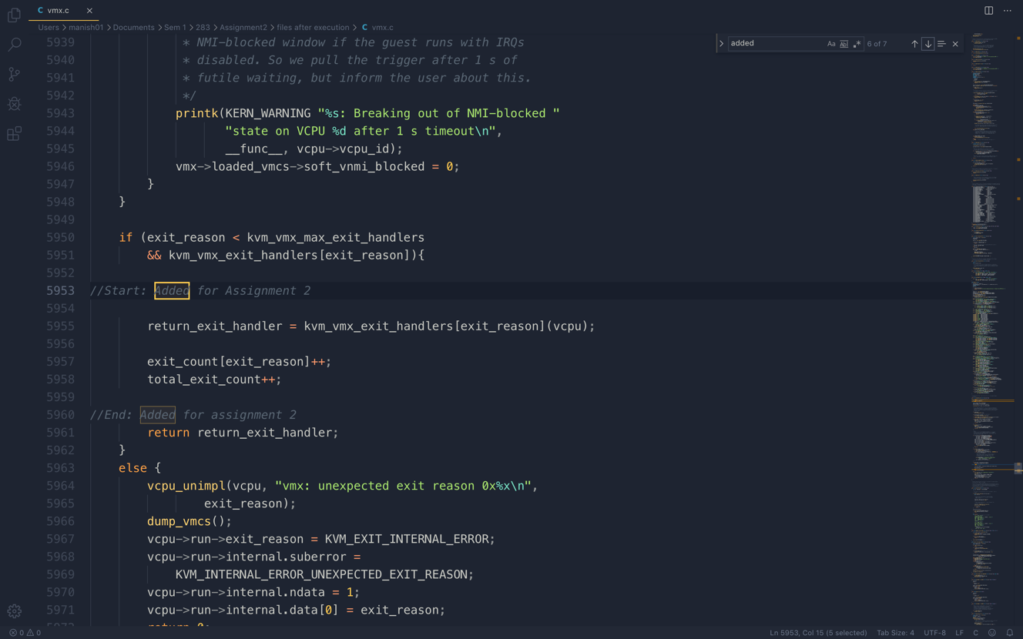

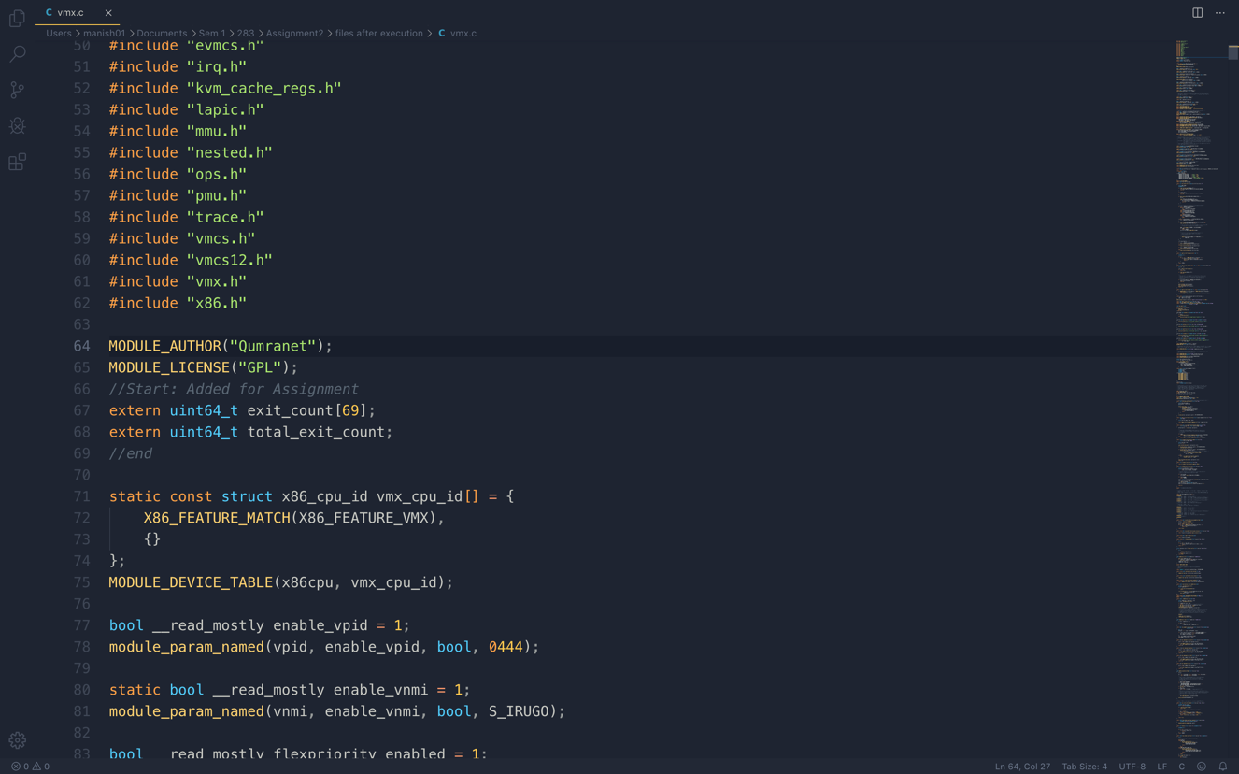

* Below is the code which we modified in cpuid.c to test the above functionality:

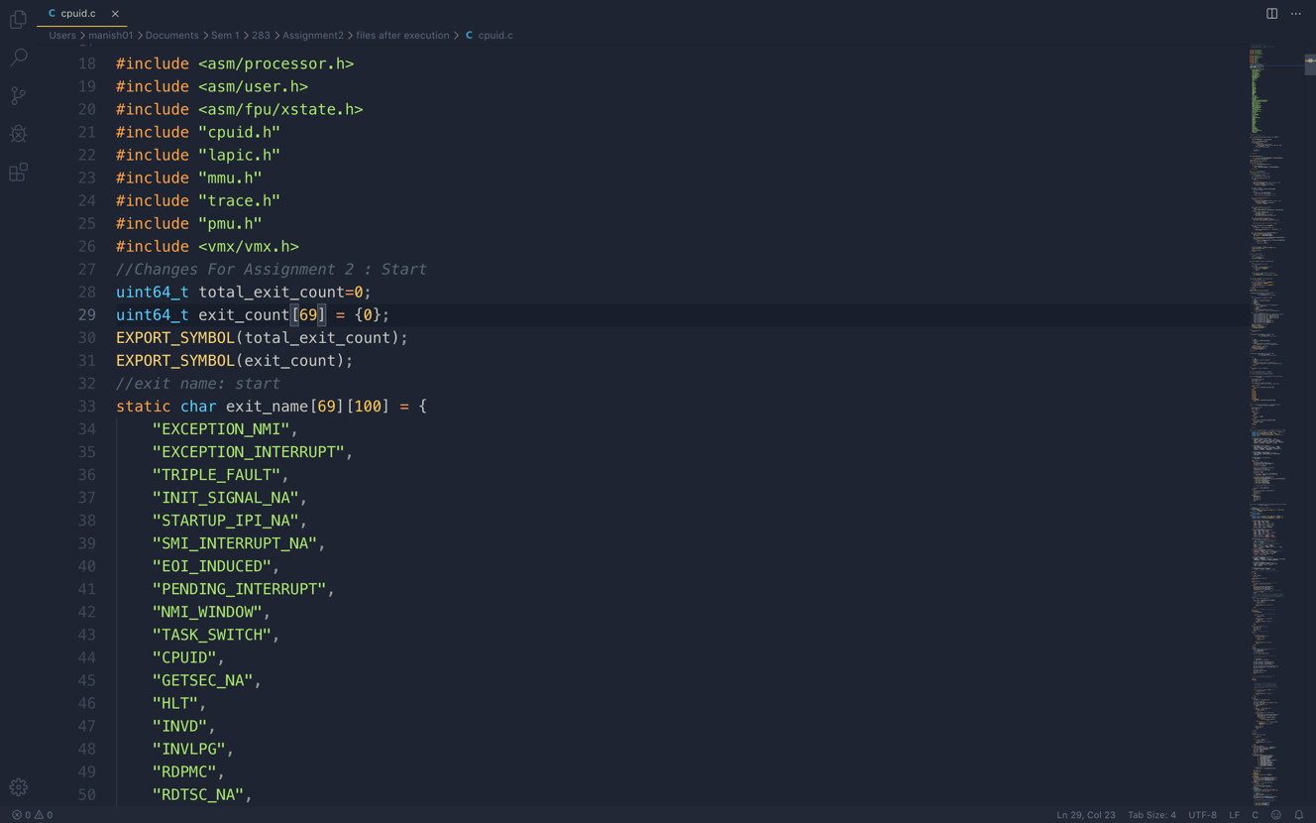

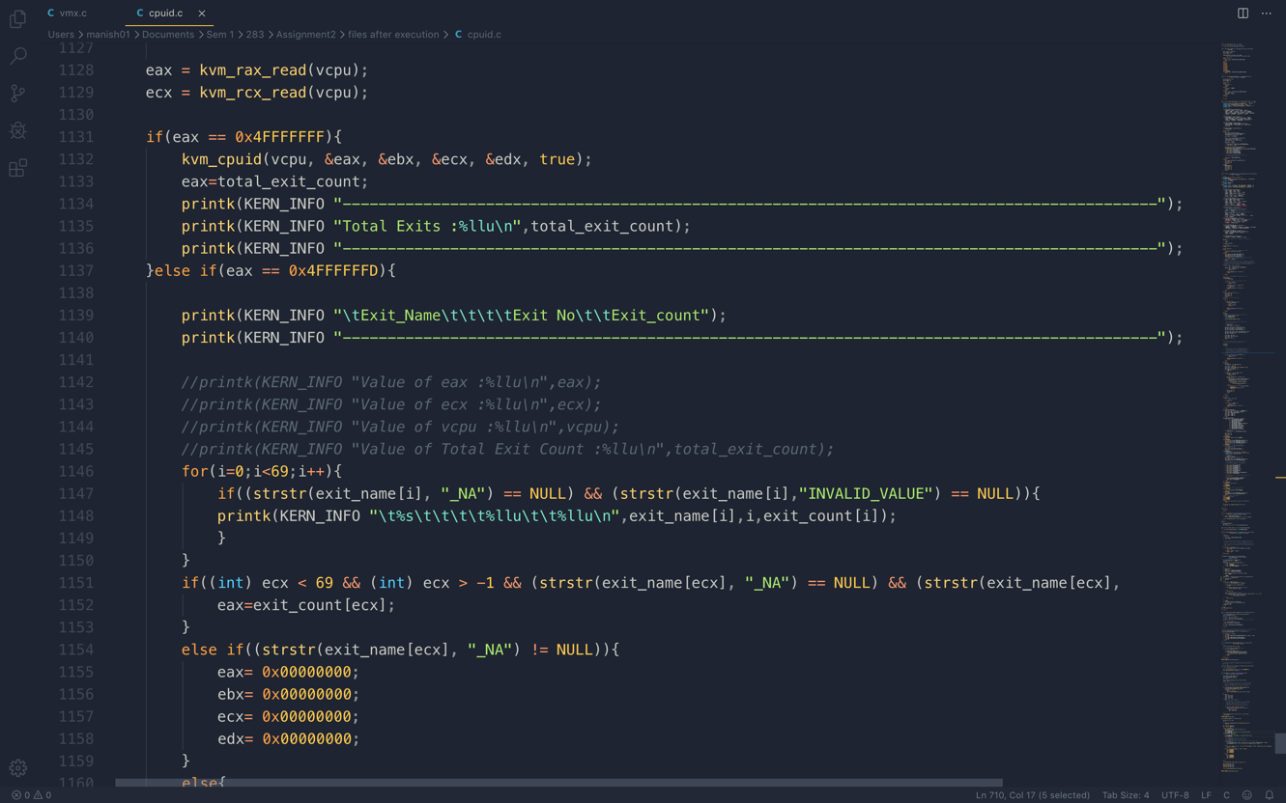

**Step 2:** Build the updated code:

* **make modules**
* **make modules_install**
* **make install**
* **Reboot**

**Step 3:** Open virt-manager and start virtual machine. Install CPUID package inside the inner vm.

* **sudo apt-get install cupid**

**Step 4:** Test the code using below commands for case 1:

1. cpuid -l 0x4FFFFFFF

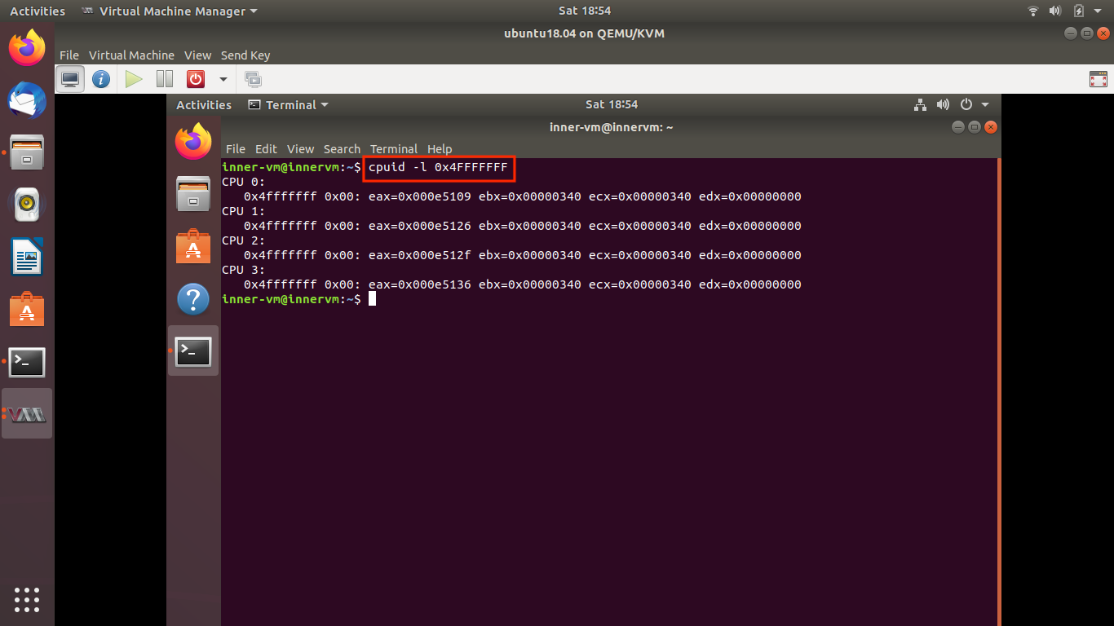

1. Try **dmesg** command in the host system’s terminal

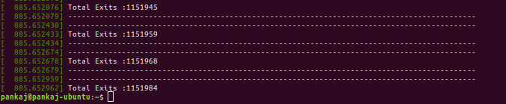

Total Exit count after rebooting

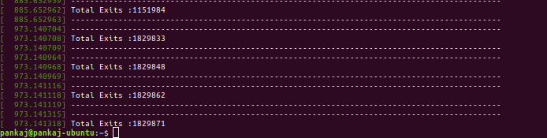

Total exits taken for VM reboot: 677887

**Step 5:** Test the code using below commands for case 2:

1. cpuid -l 0x4FFFFFFD s -12 (Exit 12)

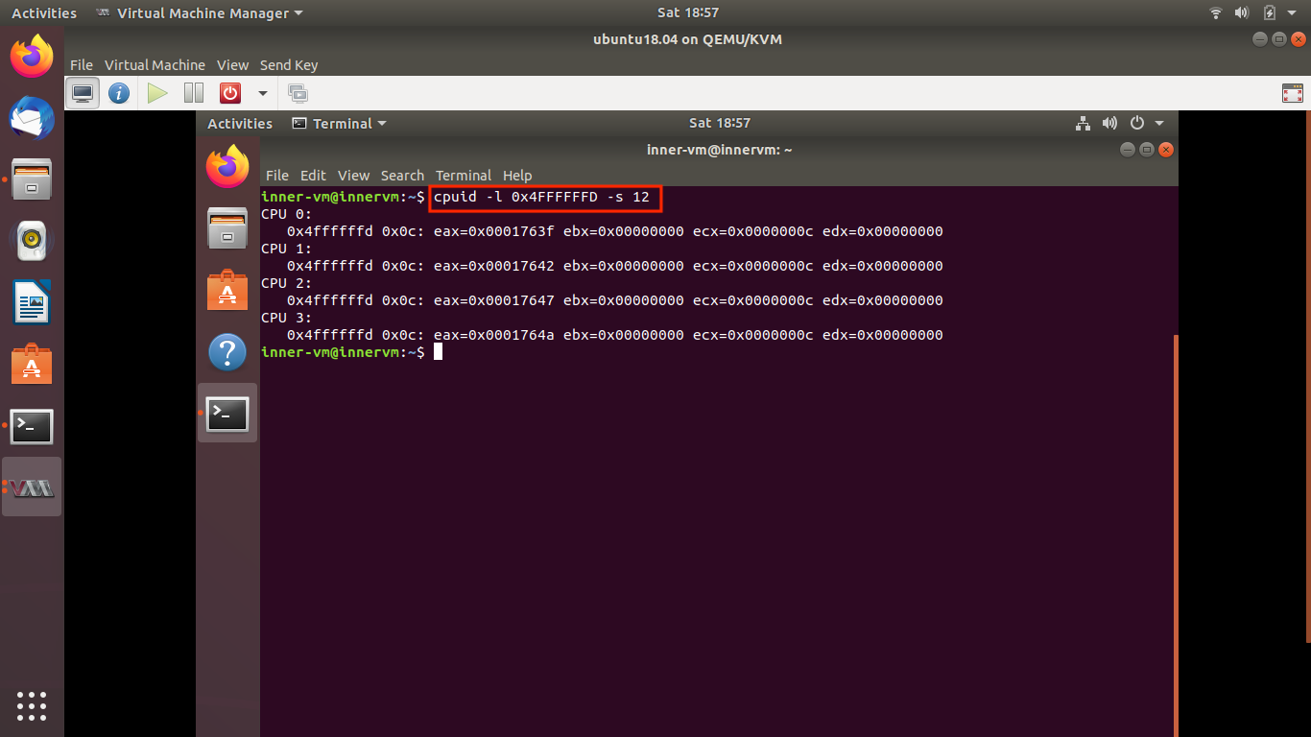

1. Try **dmesg** command in the host system’s terminal to view count of all available exits.

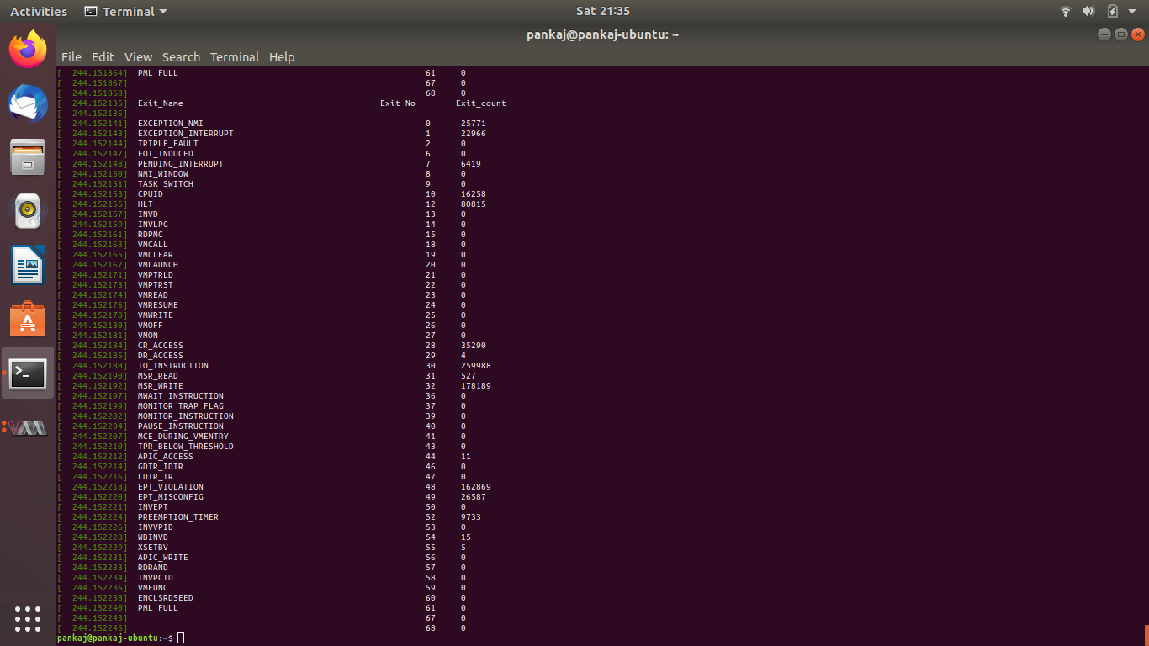

1. Cupid -l 0x4FFFFFFD s -444 to test the output for invalid exit code.

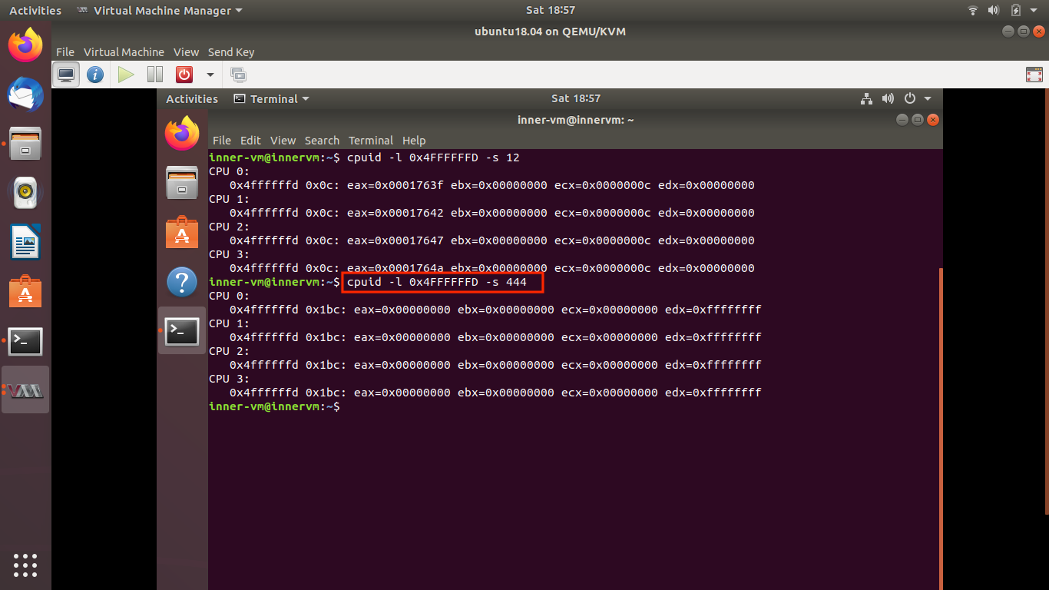

1. cupid -l 0x4FFFFFFD s -3 to test the output for valid exit but not implemented by KVM.

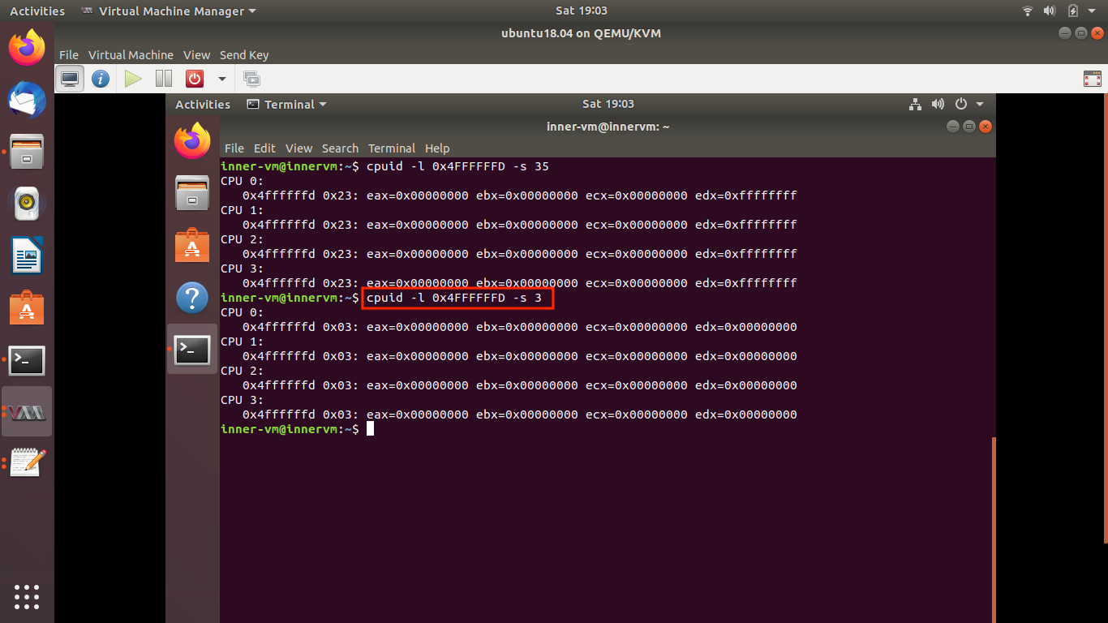

**Question 3**: Comment of the frequency of exits

**Answer:**

* Frequency of the exits are dependent on use of the system. If the system performs the more privileged operations, then the number of exits increases.

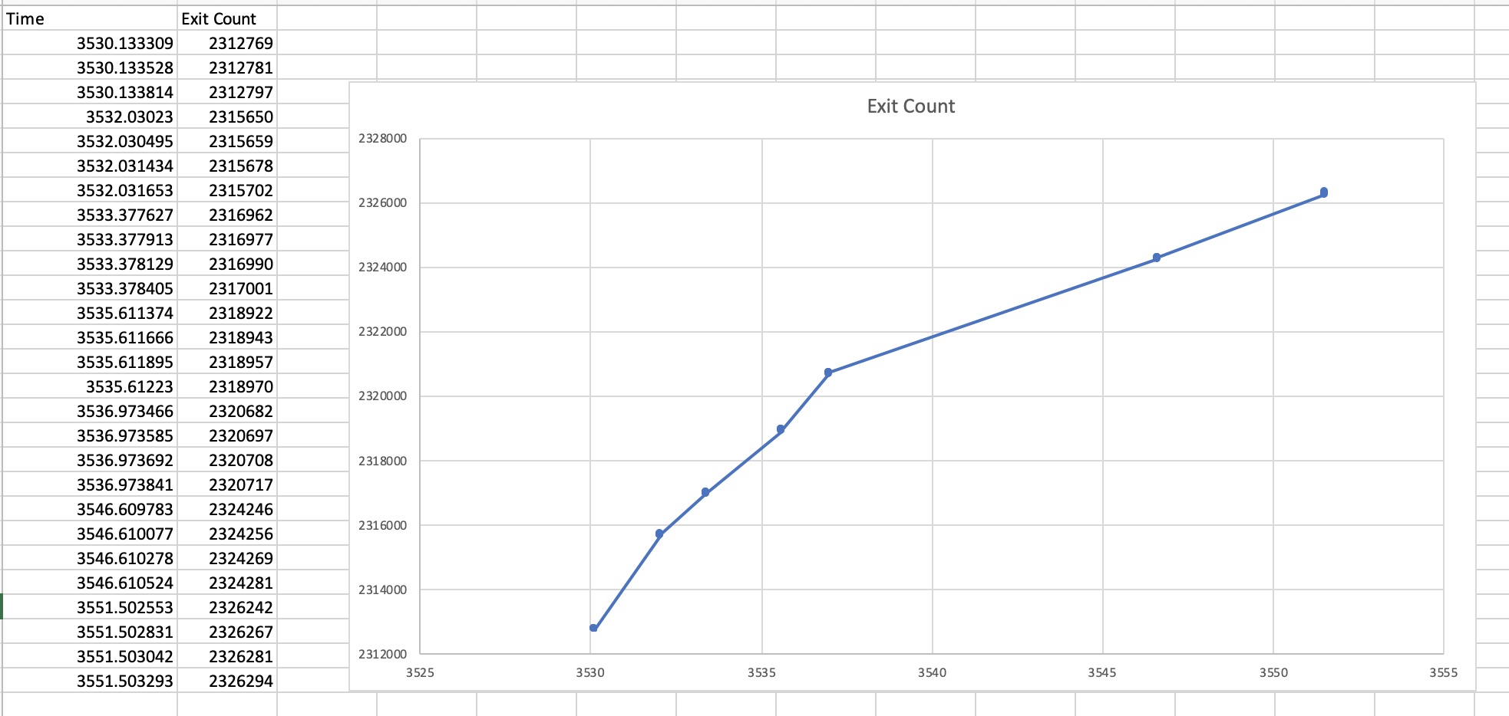

**Question 4**: Exit types defined in SDM, which are the most frequent and least frequent?

**Answer:**

* Most frequent exit is MSR_WRITE with count 605825
* Least frequent exit is DR_ACCESS with count 8 (non-zero)

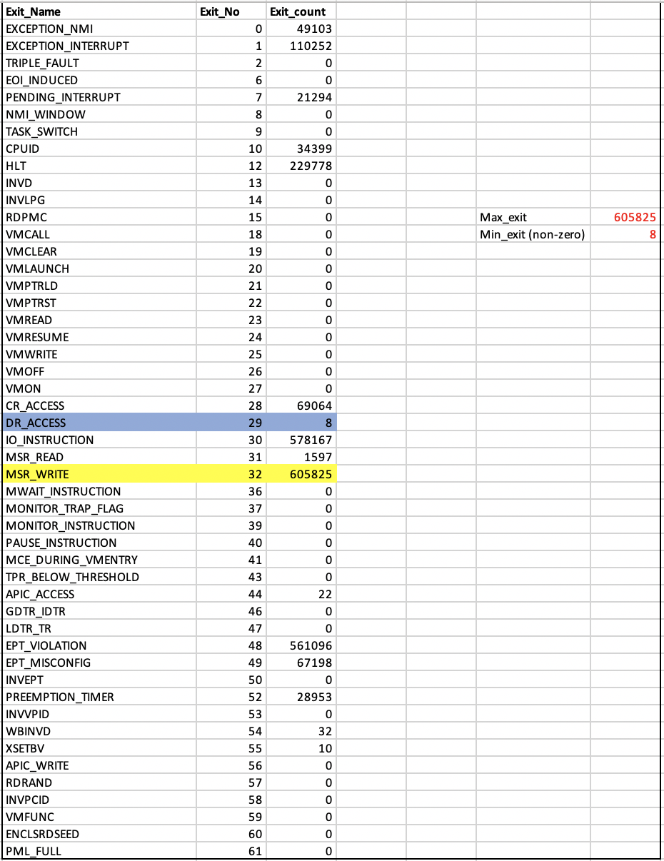

**Github repo name**: linux

**Github username** : Manish0112

**URL**: <https://github.com/Manish0112/linux>

References:

Retrieved from https://www.cyberciti.biz/tips/compiling-linux-kernel-26.html

Retrieved from https://www.linux.com/tutorials/how-compile-linux-kernel-0/